**WEEK-4 (Practice Questions)**

**1.** Given a Gaussian distribution with mean of 2 and standard deviation = 4, what is the cumulative probability at 2?

Hint: Refer to the Algebra with Gaussians spreadsheet.

***Given, X = 2; Mean = 2; Std. Deviation = 4 ; Z = X – Mean/Std. Deviation = 2 – 2/4 = 0;***

***We can get the Cumulative Probability at X = 2 (or) Z = 0 by using NORMSDIST(0) [Function in excel]***

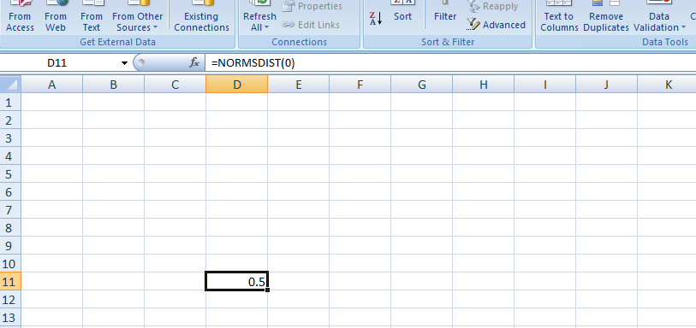

**ANSWER:- 0.5**

**2.** True/False: In order to get a sample mean that follows a Gaussian distribution, the population distribution must also be a Gaussian distribution.

**ANSWER:- False**

**3.** Assume a random variable X that follows a Gaussian distribution with mean = 10 and variance = 3, and a random variable Y, such that Y = 2X + 3. What is random variable Y’s variance?

Hint: Refer to the Algebra with Gaussians spreadsheet.

***The algebra of Gaussians is that when multiplying a Gaussian with variance x by a constant "beta" - here 2 - the new variance is beta-squared = 4 times the old variance.***

***Y = 2X+3 = (2)2 Var.(X) + 3 = (4)*(3) = 12***

**ANSWER:- 12**

**4.** Consider the example given in the Markowitz Portfolio Optimization Spreadsheet. Suppose the returns, volatility of returns, and correlation of returns of Stock 1 and Stock 2 in the spreadsheet all remain constant, and the risk-free rate increases.

[Markowitz Portfolio Optimization.xlsx](https://d3c33hcgiwev3.cloudfront.net/_92746ceb4fa7db56f9a44670bddb69b3_Markowitz-Portfolio-Optimization.xlsx?Expires=1590624000&Signature=anQUpRQ7esdcRxRbv9CDaIV4XNE1wTQjVom0cZozHy3c79GqX8b3E78Sf10XiM1rtP3xhoL856~JEBz71RlwtR~MfDyY2agMoryGvLYg1pLXZC8fYs7oc5bGoHUxYMRrzw4NXrnrk-cMKQbtGJivSrQUmpTvrohrnZfZILyyqWU_&Key-Pair-Id=APKAJLTNE6QMUY6HBC5A)

**Will the value of the optimum Sharpe ratio also increase?**

***No, it decreases ; Sharpe Ratio = E(r) – Rf / Std. Deviation***

***Given, E(r) and Std. Deviation values remain same but as Rf increases; Sharpe Ratio decreases.***

**ANSWER:- No**

**5.** Given a data set of 10 elements: {23, 17, 54, 32, 76, 88, 31, 9, 47, 26}. What is the z-score of the first element?

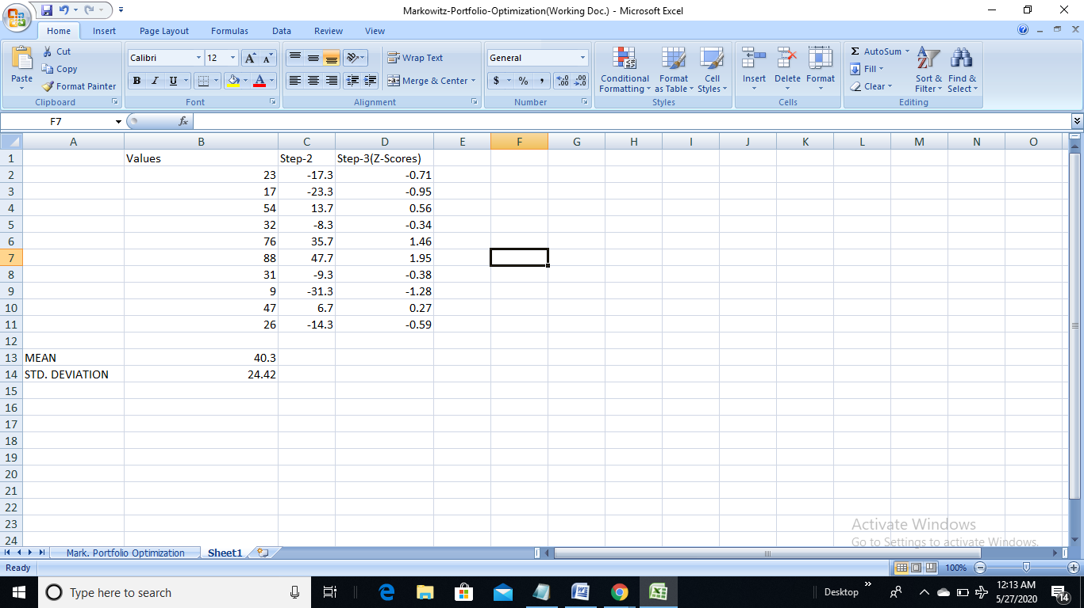

**ANSWER:- -0.71**

**6.** Suppose body weight for a large group of athletes follows an approximately Gaussian distribution with a mean of 155 pounds and standard deviation of 20 pounds. What percentage of athletes would be expected to weigh over 180 pounds?

Hint: refer the **Typical Problem with NormSDist** Spreadsheet

[Typical Problem_ NormSDist .xlsx](https://d3c33hcgiwev3.cloudfront.net/_d7203c5c9c8320637802d9db04513701_Typical-Problem_-NormSDist-.xlsx?Expires=1590624000&Signature=i4RoziSnqtN6utaFimID3or6vH-dMCu8aAVEOUazOxDXqMQIrUwr4NfFeWQjkSTVcx9vxYBocNc2VzikrwtPY8ftlKoKrM29eOknkx7uQKf5MHsCqxjQ3QJQ1jV6r2-WEJxkzZGX1e5LEmuSCC80DQrNcdrEocSkvTwDaR4803s_&Key-Pair-Id=APKAJLTNE6QMUY6HBC5A)

***Given, X = 180; Z = X – Mean / Std. Deviation; Z = 180 – 155 / 20 = 25/20 = 1.25***

***P(X>180) = 1- NORMSDIST(1.25) = 1- 0.89 = 0.11 = 10.56%***

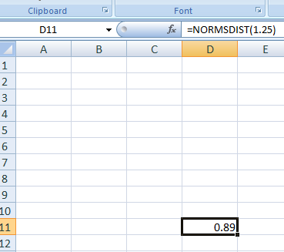 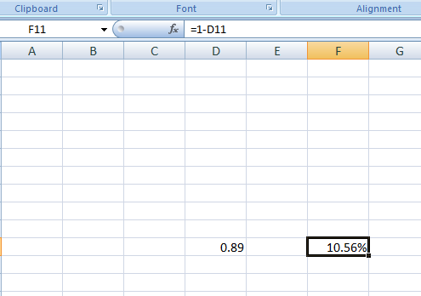

**ANSWER:- 10.6%**

**7.** Given a random variable X that follows a Gaussian Distribution with *mean = 20* and *standard deviation = 15*; and a random variable Y that follows a Gaussian Distribution with *mean = 10* and *standard deviation = 10*. Assume that X and Y are independent. What is the standard deviation of random variable Z = X +Y?

Hint: Refer to the **Algebra with Gaussians** Spreadsheet

[Algebra with Gaussians.xlsx](https://d3c33hcgiwev3.cloudfront.net/_e8b0ebbbff47c1d233134b0323d4da30_Algebra-with-Gaussians.xlsx?Expires=1590624000&Signature=YS2wIz7dwaZNihomQUaQYTMo79STAXFGLLP~S5Ai82x1ZJUfOtP9ODa2qAVXDkSiNZue0Q0N-Oq2mBYvu61AJWjBAewV04egXNFxdxLj70U1BOvwXGZk~MlrLE0q1TbW66BlMj5UhUK5YU4rvlVyRPb6IEkJQyPjcCqU9mKu7HU_&Key-Pair-Id=APKAJLTNE6QMUY6HBC5A)

Sigma(X) = 15, Sigma(Y) =10

Sigma(Z) = Sigma(X+Y)

Because X and Y are independent, this is

= SQRT ((Sigma(X))^2+(Sigma(Y))^2) = SQRT(100 + 225) = SQRT(325) = 18.03

**ANSWER:- 18.03**

**8.** Use the Markowitz Portfolio Optimization Spreadsheet. Keep the expected returns, volatility of returns, and risk-free rate constant. Change the correlation between the two stock’s returns to R = -0.5. What is the new optimum Sharpe Ratio?

[Markowitz Portfolio Optimization.xlsx](https://d3c33hcgiwev3.cloudfront.net/_92746ceb4fa7db56f9a44670bddb69b3_Markowitz-Portfolio-Optimization.xlsx?Expires=1590624000&Signature=anQUpRQ7esdcRxRbv9CDaIV4XNE1wTQjVom0cZozHy3c79GqX8b3E78Sf10XiM1rtP3xhoL856~JEBz71RlwtR~MfDyY2agMoryGvLYg1pLXZC8fYs7oc5bGoHUxYMRrzw4NXrnrk-cMKQbtGJivSrQUmpTvrohrnZfZILyyqWU_&Key-Pair-Id=APKAJLTNE6QMUY6HBC5A)

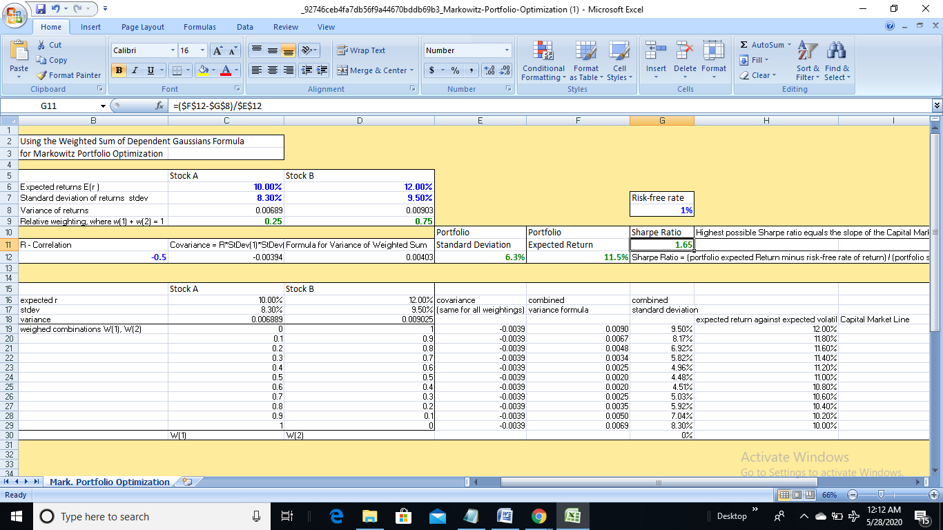

***The value of 1.65 what you have seen above is before optimization of w1 and w2 (i.e w1=0.25 and w2 =0.75 as in sheet originally) after changing correlation. We must use MS solver with new correlation value with Sharpe Ratio as Target Cell (G11) and option to maximize it by changing W1 cell (C9) with constraint W1 >= 0 and W1<=1. W2 is automatically calculated in the work sheet since W2=1-W1. You can see you value for w1 and w2 and Sharpe ratio.***

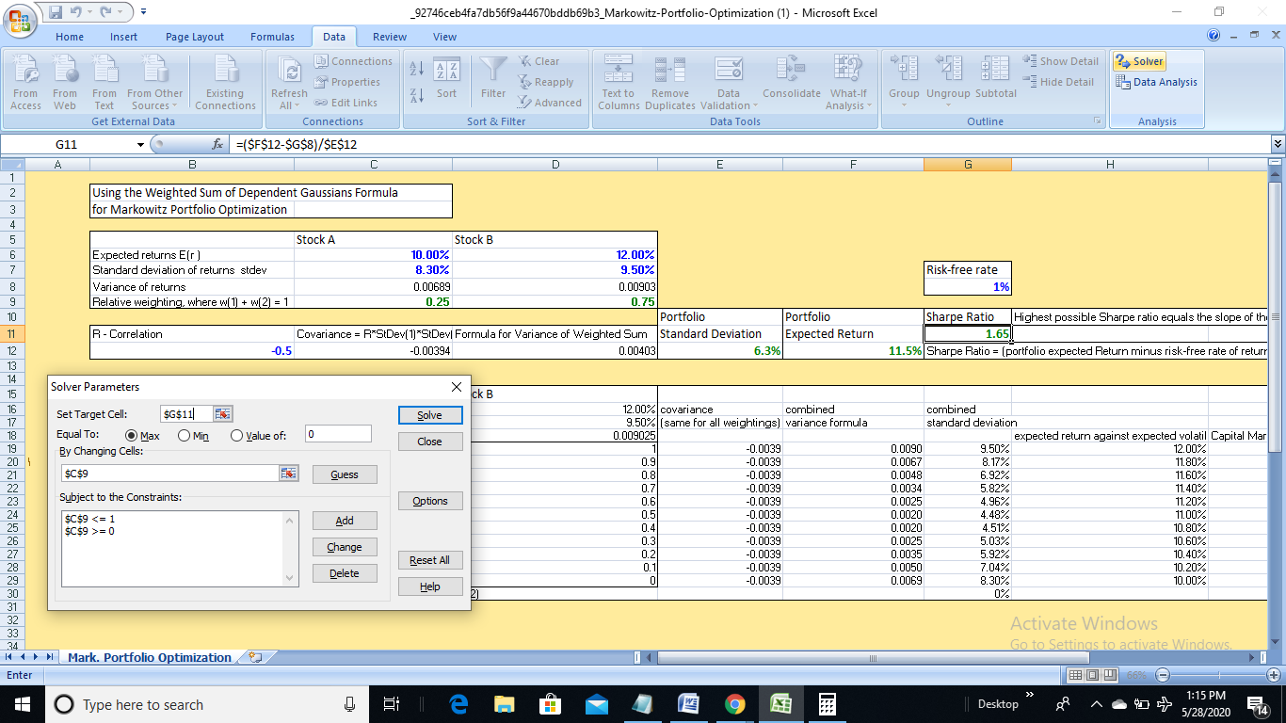

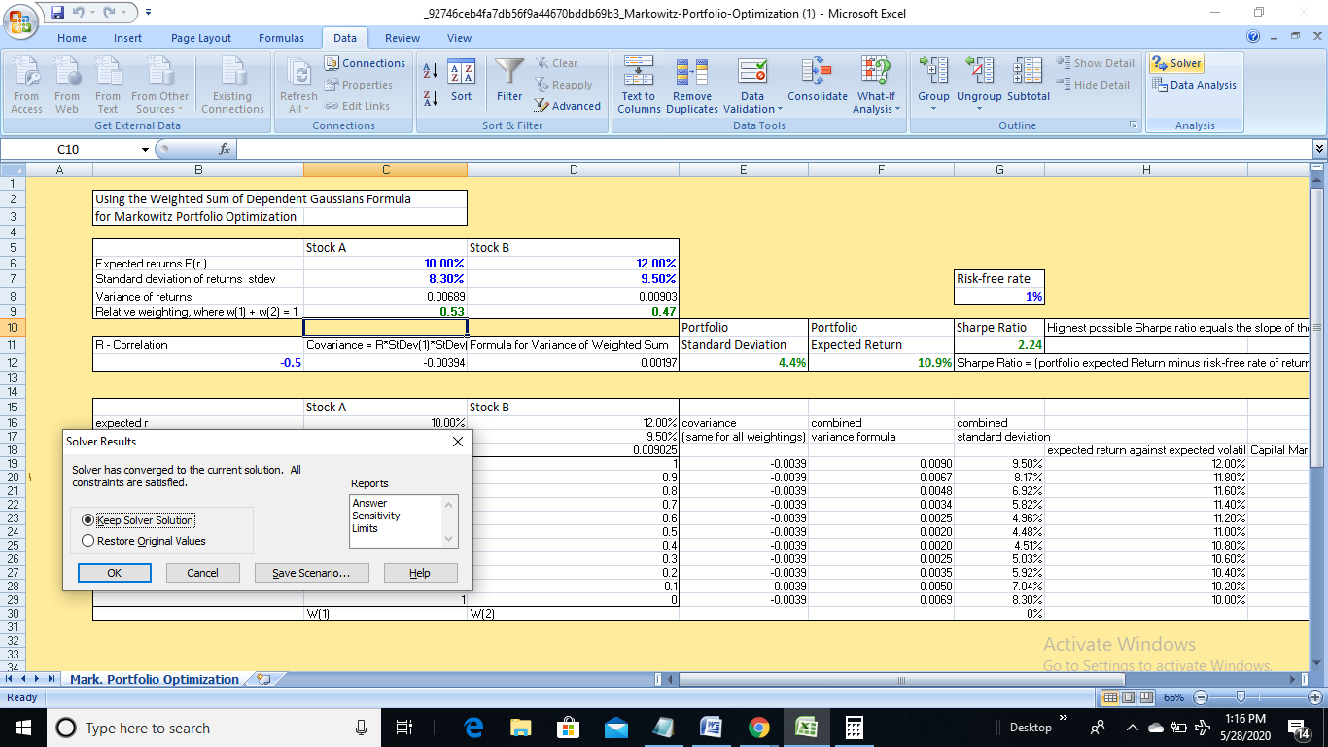

**ANSWER:- 2.24**